**Pre lab questions**

1. (predict) Which cut would regenerate the zebrafish fin faster?

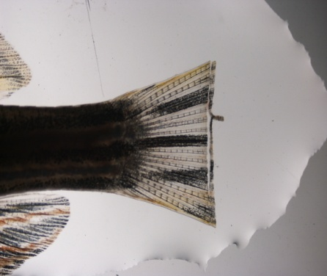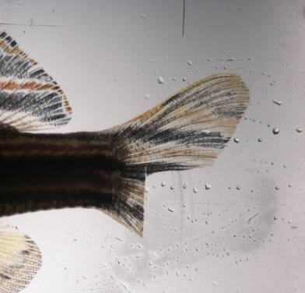

**A B**

2. What is the control in this experiment?

3. We will be using **(dissecting, compound)** microscope with **(bright, dark)** field to observe the fin regeneration.

4. Why are zebrafish a good model for studying regeneration (3 reasons)?

5. What is your hypothesis for this experiment?

**Post lab questions**

1. What did you learn from this lab?

2. What kind of techniques did you use in this lab?

3. What were your results from this lab? Is your hypothesis supported? And why?